SIMATS ENGINEERING

ASSESSMENTTOOL 2

COURSE NAME: Artificial Intelligence COURSE CODE: CSA1 7

COURSE OUTCOME COVERED





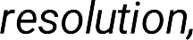

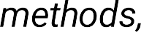









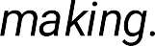
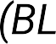
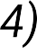





Time Duration: 30 Minutes
QUESTIONS: 30 Total Marks:30

Annexure A

MCQ




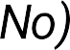



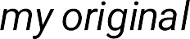


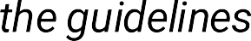




Annexure A

Circle the most appropriate option for each question.

Q1 . Which of the following best describes a Logical Agent in AI?
- An agent that reacts randomly to the environment c) An agent that only follows pre-defined scripts
- An agent that uses a knowledge base and logical d) An agent that learns from rewards inference to decide actions

- ¬Q → ¬P only






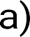


- Both b and c

Q3. Conjunctive Normal Form (CNF) requires the formula to be expressed as:
- Adisjunction of conjunctions c) Aconjunction ofliterals only
- Aconjunction ofdisjunctions (clauses) d) Asequence of implications

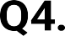





- Some students pass c) If something passes, it is a student
- Every entity that is a student passes d) There exists at least one student who

Q5. Unification in FOL is the process of finding substitutions that:
a) Convert clauses to CNF c) Prove a goal using backward
chaining

Q6. In the Resolution algorithm, deriving the empty clause □ indicates:
- The knowledge base is consistent c) Acontradiction — the original goal is proven
- The negated goal is satisfiable d) More clauses need to be added

Q7. Forward Chaining is best described as a strategy.
- Goal-driven / top-down c) Heuristic-based depth-first
- Data-driven / bottom-up d) Probabilistic inference

Q8. Backward Chaining begins reasoning from:
a) All known facts toward a conclusion c) Arandom clause in the knowledge
base

Q9. Which step is NOT part of converting a sentence to CNF?
- Eliminate bicon di ti ona ls (↔ ) c) Apply Skolemization toremove existential quantifiers
- Move negations inward using De Morgan’s laws d) Distribute AND over OR

Q10. Knowledge Engineering in FOL involves:
- Training a neural network on domain-specific data c) Writing heuristic search strategies
- Defining domain concepts, relations, and axioms d) Encoding reward functions forreinforcement learning formally in FOL







- ¬Q is true c) P is uncertain
- Q must be true d) The KB is inconsistent

Q12. The Most General Unifier (MGU) is the substitution that:
- Is the most specific possible match c) Eliminates all variables from a clause
- Makes two terms identical with minimal variable d) Applies resolution toproduce CNF binding

Q13. Which inference method is more appropriate when a specific goal is known?
- Forward Chaining c) Backward Chaining
- Truth Table method d) A* search

Q14. Propositional Logic differs from First Order Logic because it:
- Supports probabilistic reasoning c) Is always more expressive
- Cannot represent objects, relations, or quantifiers — d) Handles uncertaintybetter only truth values of atomic propositions

Q15. Resolution Refutation proves a goal G by:
- Directlyderiving G from the KB using forward chaining c) Checking G in the truth table
- Adding ¬G to the KB and deriving a contradiction d) Applying Modus Tollens repeatedly (empty clause □ )

Q16. Learning from observation in AI refers to:
- An agent receiving numerical rewards from the c) Acquiring knowledge byfollowing explicit symbolic environment rules
- Improving performance byexamining examples or d) Memorizing a fixed dataset without generalization experience from the environment

Q17. Inductive learning is best described as:
- Deriving specific conclusions from general rules c) Memorizing training data exactly
- Generalizing a hypothesis from specific training d) Applying search algorithms to find optimal policies examples

Q18. In a Decision Tree, what does each internal node represent?
- A class label / output decision c) A test on an attribute / feature
- Aprobabilitydistribution over outcomes d) Atraining data sample

Q19. Explanation-Based Learning (EBL) differs from inductive learning because it:
- Requires largeamounts of training data togeneralize c) Uses prior domain knowledge toexplain and generalize
a single example
- Learns onlyfromnumeric data using regression d) Applies unsupervised clustering tofind hidden patterns

Q20. In statistical learning, a Naive Bayes classifier assumes:
- All features are conditionally dependent on each other c) All features areconditionally independent given the given the class class label
- The data must follow a uniform distribution d) Labels are determined by a reward function

Q21 . Learning with complete data (no hidden variables) in a Bayesian network involves:
a) Using the EM algorithmto estimate missing values c) Directlycomputing maximum likelihood estimates from
observed data

b) Training a deep neural network with dropout
d) Applying reinforcement signals to update

Q22. The Expectation-Maximization (EM) algorithm is used when:
- Training data is fully labeled and no variables are c) The dataset contains hidden (latent) variables that hidden cannot be directly observed
- An agent explores an unknown environment using trial d) Backpropagation fails toconverge in a neural network and error

Q23. In a Neural Network, the activation function serves to:
- Initialize the weights ofeach neuron to zero c) Introduce non-linearityto enable learning ofcomplex
patterns
- Normalize the input dataset before training d) Store previously learned examples in memory

Q24. Which of the following correctly describes backpropagation in a neural network?
- Weights are updated in the forward pass using input c) The error is propagated backward from output to input gradients layers toadjust weights
- Outputs of each layer arestored and reused in later d) Aseparate model is trained for each hidden layer epochs independently

Q25. A Support Vector Machine (SVM) — a type of kernel machine — classifies data by:
- Minimizing the number oftraining examples used c) Finding the maximum-margin hyperplane that
separates classes
- Grouping similar data points into clusters using d) Updating weights using Q-values from an environment centroids

Q26. The kernel trick in kernel machines (SVMs) allows:
- Reducing the number ofsupport vectors needed c) Operating in a high-dimensional feature space without
explicitly computing coordinates
- Accelerating gradient descent convergence d) Replacing hidden layers in a deep neural network

Q27. In Reinforcement Learning, the agent aims to maximize:
- Classification accuracy on a fixed test set c) Cumulative reward received over timethrough
interaction with the environment
- The number of features selected from the training data d) The size ofthe neural network hidden layer

Q28. The Q-Learning algorithm in Reinforcement Learning is classified as:
- Asupervised learning algorithmrequiring labeled c) Amodel-free, off-policytemporal difference learning datasets method
- An unsupervised clustering technique using centroids d) Adecision-tree-based ensemble classifier

Q29. Overfitting in machine learning occurs when:
- The model performs poorly on both training and test c) The model fits training data tooclosely and data generalizes
poorly to newdata
- The learning rate is set too low during gradient descent d) The training sethas more features than training

Q30. Which of the following best distinguishes Reinforcement Learning from Supervised Learning?
- RL uses labeled input-output pairs; SL uses reward c) RL learns via trial-and-error with reward feedback; SL signals learns from labeled examples
- Both RL and SL require explicit reward functions d) RL is always faster to converge than SL on any

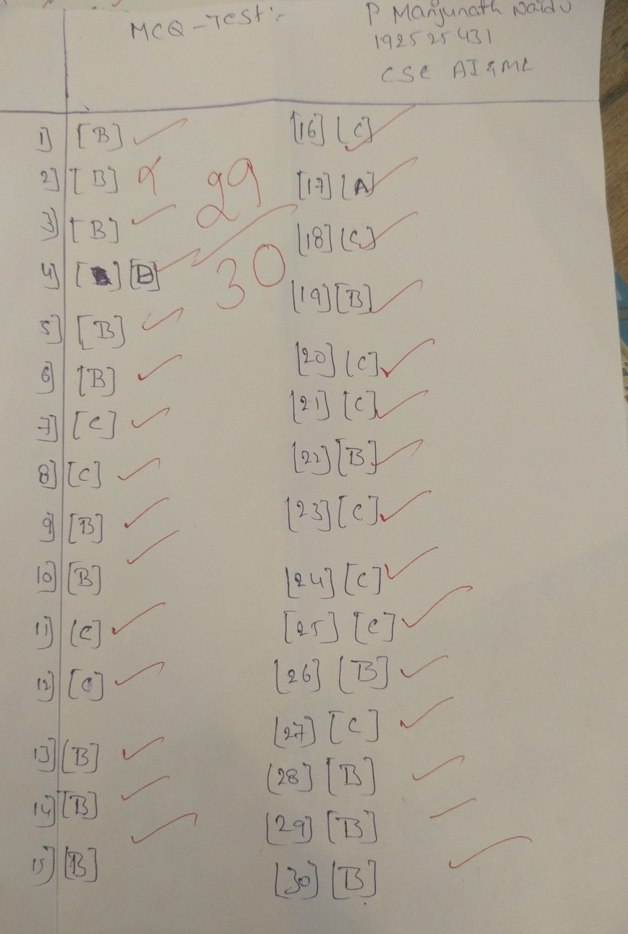

RUBRICS FOR CALCULATION

Criteria | Weightag  e (%) | Level 4  (Exemplary) | Level 3  (Proficient) | Level 2  (Developing) | Level 1  (Beginning)
Conceptual  Understanding | 30% | Demonstrates thorough understanding; answers all questions  accurately | Shows good understanding with few errors | Partial understanding; several incorrect responses | Lacks understanding; majority of answers incorrect
Accuracy of  Answers | 25% | All answers are correct | Most answers  are correct with  minor mistakes | Some correct  answers;  frequent errors | Mostlyincorrect answers
Application of Knowledge | 20% | Correctlyapplies concepts to problem-based  questions | Applies concepts with minor errors | Limited ability to apply concepts | Unable to apply concepts
Time  Management | 15% | Completes quiz well within time  efficiently | Completes on time with minor  delays | Requires extra  time or rushes through questions | Unable to complete within  given time
 |  | Interprets all
Question  Interpretation | 10% | questions correctlyand responds  appropriately | Misinterprets a few questions | Often  misinterprets  questions | Unable to  understand  questions

